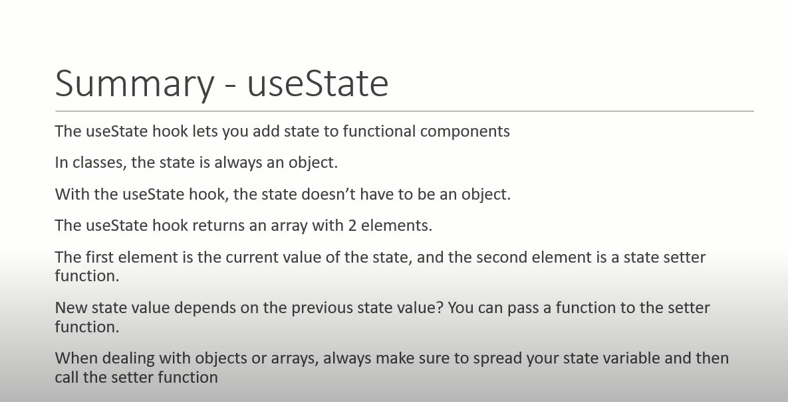

Example 1 : Class Simple example Without hook

import React, { Component } from 'react'

class ClassCompCounter extends Component {

    constructor(props) {

      super(props)

      this.state = {

         count:0

      }

    }

    incrementCount=()=>{

        this.setState({

            count : this.state.count + 1

        })

    }

  render() {

    return (

      <div>

        <button onClick={this.incrementCount}>Count {this.state.count}</button>

      </div>

    )

  }

}

export default ClassCompCounter

Example 2 : useState Hook

import React,{useState} from 'react'

function FunctionalCompCounter() {

 const [count,setCount]=useState(0)

  return (

    <div>

      <button onClick={()=> setCount(count+1)}> Count  {count}</button>

    </div>

  )

}

export default FunctionalCompCounter

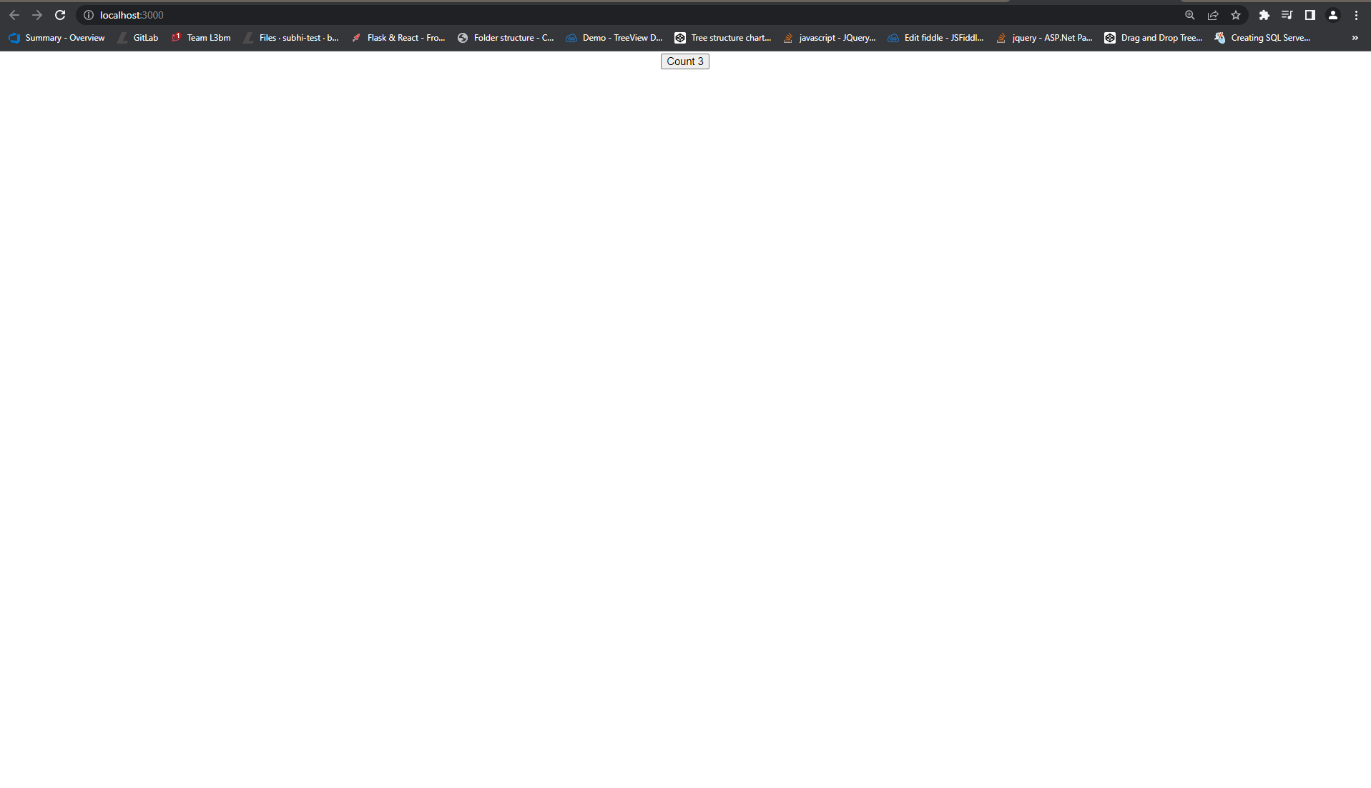

Example 3 : useState With previous state:

import React, {useState} from 'react'

function UseStateWithPreviousState() {

    const initialCount=0

    const [count, setCount]=useState(initialCount)

    const incrementFive = () => {

        for(let i=0;i<5;i++){

            setCount(prevCount => prevCount + 1)

        }

    }

  return (

    <div>

      Count : {count}

      <button onClick={()=>setCount(initialCount)}>Reset</button>

      <button onClick={()=>setCount(prevCount => prevCount+1)}>Increment</button>

      <button onClick={()=>setCount(prevCount=>prevCount-1)}>Decrement</button>

      <button onClick={incrementFive}>Increment 5</button>

    </div>

  )

}

export default UseStateWithPreviousState



Example 4: useState with object:

 import React, {useState} from 'react'

 function UseStateWithObject() {

    const [name,setName] = useState({firstName:'',lastName:''})

   return (

     <div>

       <form>

        <input

        type='text'

        value ={name.firstName}

        onChange={e=> setName({...name, firstName : e.target.value})}/>

        <input

        type='text'

        value ={name.lastName}

        onChange={e=> setName({...name, lastName : e.target.value})}/>

        <h2>Your firstName is - {name.firstName}</h2>

        <h2>Your lastName is - {name.lastName}</h2>

        <h2>{JSON.stringify(name)}</h2>

       </form>

     </div>

   )

 }

 export default UseStateWithObject

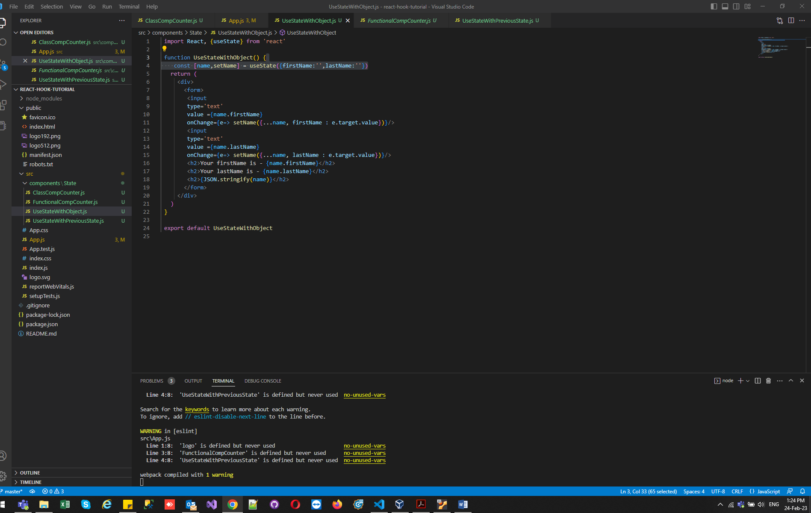

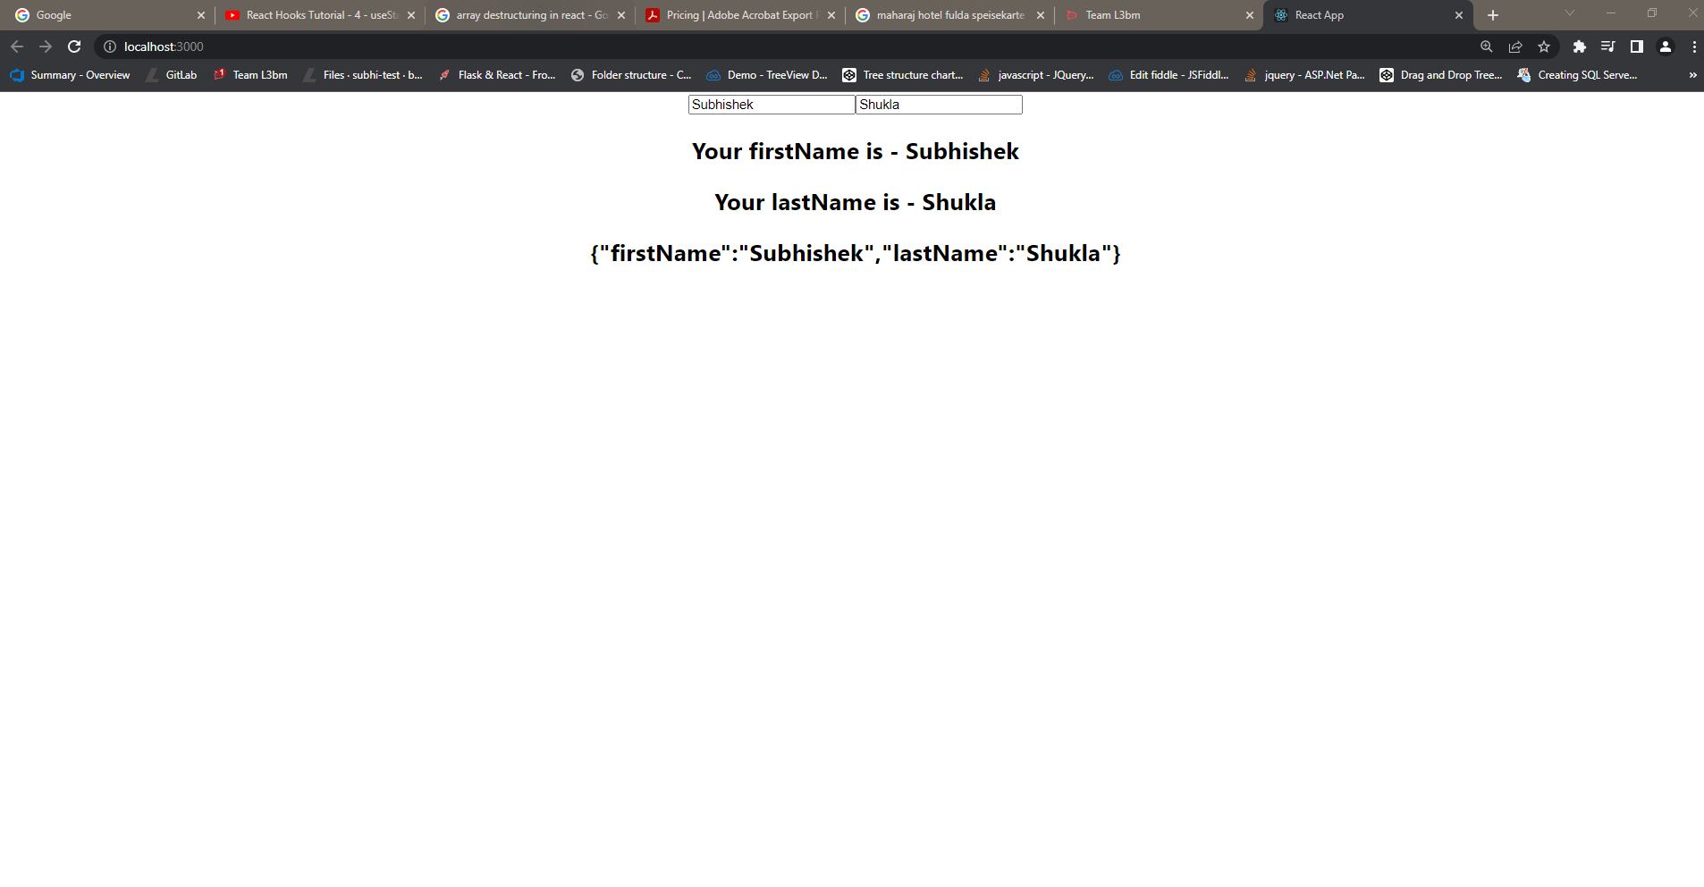

Example 5: useState with Array:

import React,{useState} from 'react'

function UseStateWithArray() {

    const[items, setItems]=useState([])

    const addItem=()=>{

        setItems([...items,{

            id:items.length,

            value: Math.floor(Math.random() \* 10) + 1

        }])

    }

  return (

    <div>

      <button onClick={ addItem }>Add a number</button>

      <ul>

        {

            items.map(item => (

                <li key={item.id}>{item.value}</li>

            ))

        }

      </ul>

    </div>

  )

}

export default UseStateWithArray

